http://toolsqa.com/selenium-webdriver/page-object-pattern-model-page-factory/
If some locators are changed, you have to walk through the whole test code to adjust locators where necessary. By using the page object model we can make non-brittle test code and reduce or eliminate duplicate test code.
There are two different ways of implementing POM:
Regular Java classes: Page Object Model
Page Factory Class

We should use Page Object Model instead of Page Factory. Because Page Object Model is easier to learn.

Why using Page Object Model instead of just using config.properties file to store web elements?
Think of a scenario where you have a Webpage and it has multiple sections, multiple frames and hundreds of WebElements. Obviously you do not want that once you type the page name and it will give you all the elements available on the webpage. If there are few elements, it is fine to have the same structure but if there are many then it is advisable to divide your page in to different sections for e.g. header, footer, left navigation, center content and right navigation. Then categories each WebElement under their parent element.
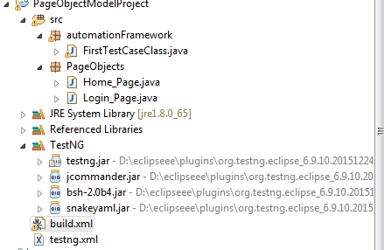
In this project, we use different page objects. Each page object contains web elements. For example: Login_Page.java contains list of elements on Login page...
package PageObjects;

import org.openqa.selenium.By;
import org.openqa.selenium.WebDriver;
import org.openqa.selenium.WebElement;

public class Login_Page {

private static WebElement element = null;

public static WebElement usernameFld(WebDriver driver){
element = driver.findElement(By.xpath("html/body/div[2]/form/div[1]/div/div/input"));
return element;
}

public static WebElement passwordFld(WebDriver driver){
element = driver.findElement(By.xpath("html/body/div[2]/form/div[2]/div/div/input"));
return element;
}

public static WebElement logInBtn(WebDriver driver){
element = driver.findElement(By.xpath("html/body/div[2]/form/div[3]/button"));
return element;
}

}

package automationFramework;

import org.openqa.selenium.By;
import org.openqa.selenium.WebDriver;
import org.openqa.selenium.WebElement;
import org.openqa.selenium.firefox.FirefoxDriver;
import org.testng.annotations.Test;

import PageObjects.Login_Page;

public class FirstTestCaseClass {
@Test
public void FirstTestCaseMethod(){
WebDriver driver = new FirefoxDriver();
driver.get("http://172.19.7.30/gtc/");
Login_Page.usernameFld(driver).sendKeys("minhql.rt");
Login_Page.passwordFld(driver).sendKeys("Whatever10");
Login_Page.logInBtn(driver).click();
}
}

Đường dẫn trong windows là dấu \
Đường dẫn trên web là dấu /

Ở Login_Page.java ta đã đặt từ modifier public static, nên ở FirstTestCaseClass ta không cần instantiate nó nữa (Không cần viết Login_Page login = new Login_Page() và cũng không cần import Login_Page). Để gọi element của trang login ta chỉ cần Login_Page.usernameFld, dùng cách này truy cập element nhìn sẽ có tổ chức hơn, biết được element nào thuộc page nào....Còn nếu ta dùng config.properties để chứa element thì ta phải viết như sau:
Properties pro = new Properties()
FileReader in = new FileReader("C:\\eclipseee\config.properties");
pro.load(in);

WebElement usernameFld = driver.findElement(By.xpath(pro.getProperty("usernameFld"));
Lấy element dùng config.properties thì viết dài hơn nên ta dùng PageObject vừa ngắn vừa dễ tổ chức.

